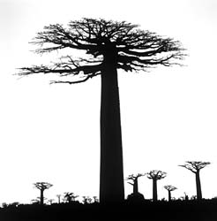
Biological Design Experiment in Arid Urban Regions

Multi scale faceted experiments for effective testing of vegetative growth, design tools, bio groups and their effect on micro climate.

Tom Bosschaert & Haley Gilbert

Construction of urban areas in arid regions is occurring at an alarming rate across the globe. As desertification fringes upon more and more land and population increases drive the demand for more urban areas, there is more development taking place in arid regions. Desertification and urbanization work in opposition traditionally, with urbanization exacerbating desertification but what if urbanization reversed the trend towards desertification. Could urbanization reduce the amount of land that is converted to desert?

“’Designed experiments’ propose going beyond current strategies… to insert architecturally designed experiments into the urban mosaic.” (Felson and Pickett 2005)

In order to research and conduct ecological experiments in urban areas, it is advantageous to use “designed experiments.” By using a “designed experiment,” testing can be conducted on urban areas in arid regions to experiment with steetscapes and rooftops to reduce the effects of desertification and change the microclimate of an arid urban area.

The experiment will convert streetscapes to greenscapes and rooftops to greenroofs in controlled sections of the urban area. These two design strategies will be constructed to manage stormwater runoff, provide vegetated corridors/spaces, maintain local biodiversity, and reduce energy loads. The greenscapes will be supported by grey water and treated wastewater from locally sourced water treatment centers. The greenroofs would sustain themselves on the limited annual precipitation alone.
Over time, testing would occur to see if the microclimate of the city changed with increased vegetation, the energy demand of the city decreased with streetscape shading and greenroof insulation, the temperature of the city decreased with increased vegetation, shading and insulation, and if grey water and treated water is sufficient to support vegetation in greenscapes in an arid urban environment.

Introduction

What we know
Although there is research examining green streets, low-impact development strategies and green roofs in urban areas there is no research examining these design strategies in arid regions. Also, there is little research conducted on the irrigation strategies used to support various vegetation plantings in arid urban areas.
The literature supports the economic, social and environmental benefits of constructing green streets and greenroofs in urban environments. The City of Portand, Oregon operates a successful green streets program. They cite the benefits of green streets to include: reduced polluted stormwater runoff, improved pedestrian and bicycle safety, increased urban green space, reduced infrastructure costs for sewer collection, improved air quality and reduced air temperatures (City of Portland, Oregon; Greenstreets Program, Bureau of Environmental Science http://www.portlandonline.com/BES/index.cfm?c=eeeah). Greenroofs also provide aesthetic, environmental and economic benefits by providing urban green space, providing habitat for biodiversity, reducing stormwater runoff, reducing the temperature of buildings, thus energy load of buildings, and extending the life of the roof membrane(Voelz 2006).

Also, there is current research that links shade trees and cool surfaces to reductions in energy use and improvements in air quality in urban areas. Planting street level trees and utilizing high albedo surface materials can reduce air conditioning use and reduce outdoor air temperatures thus reducing energy loads in a city (Akbari, Pomerantz et al. 2001).

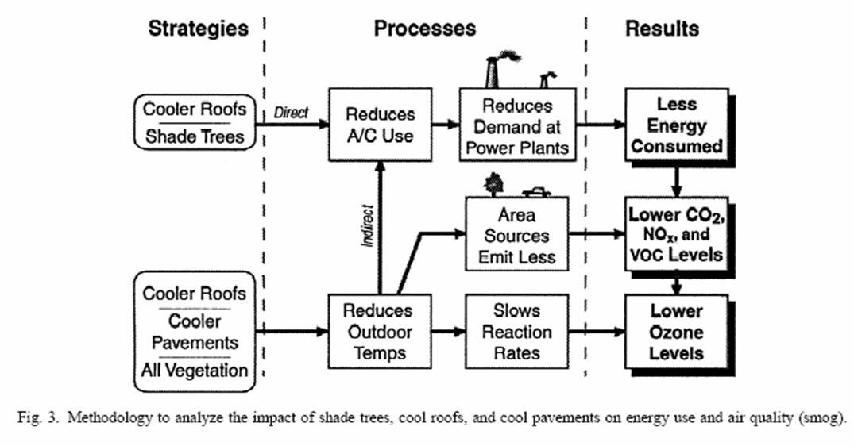
What we don’t know
However, there is a gap in the research. There is no current research that combines these two strategies and their correlated benefits in a sustainable design for an arid urban area. The proposed “designed experiment”, presented here, will combine and utilize both greenroofs and greenscapes design strategies to reduce the effects of desertification and change the microclimate of an arid urban area.

The greenscapes will convert under-utilized streetscapes into productive, vegetatated patches. These greenscapes will take form along sidewalks and in the centers of promenades and streets as planting basins. They will connect to form long corridors stretching ecological fingers through the city. In order to transform the micro-climate and to support any diverse plant varieties the soil and absolute humidity will need to gradually build up. In order for that to occur, plantings will mimic the natural vegetation pattern of the region. Plantings will occur over four stages, first starting with minimal native desert plantings in small circular formations then spreading to a labyrinth pattern with increased water, onto a vegetated patch with holes remaining bare and lastly to a completely vegetated space over the span of ten to fifteen years. Increases in water directly correlate to the advanced stages of the vegetation process so as more water is available to plants, they will grow in this pattern ((von Hardenberg, Meron et al. 2001).

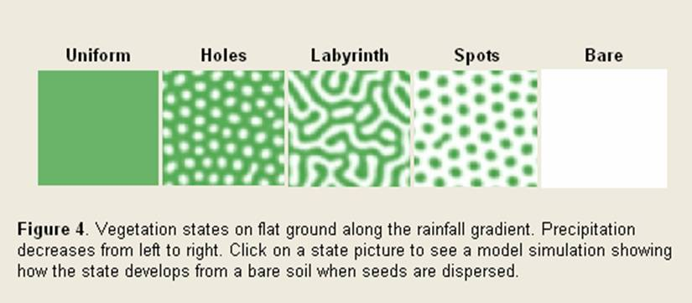

Since arid regions are extremely hot with sparse precipitation, design interventions are required to support the greenscapes. The planting basins will need to be constructed along a north south access to reduce direct exposure to the sun and shading structures will need to be installed to reduce the evaporation of moisture from the soil and plants. The need for these shading structures will decrease over time once a succession of species is present to provide natural ground coverage and varying levels of shading. Buildings can also be used to provide shading during certain times of the year and day with proper siting and heights. To advance the natural vegetation pattern in the desert, more water needs to be made available. Data from United Arab Emirates reveals that the region receives only two inches of precipitation per year, during heavy storms in the winter months. To provide water in a sustainable way, the planting basins will be irrigated from localized treated wastewater and grey water but will capitalize on the strong winter storms by retaining the stormwater runoff that will be directed from all impervious surfaces into the planting basins. The treated wastewater required for the greenscapes is generated by localized wastewater treatment facilities. These facilities will operate on a one to five block scale.

Greenroofs will lace the rooftops across the best management zone. These rooftops will support greenroof systems comprised of succulents and plant mediums that retain stormwater and insulate the building, thus reducing energy demands from air conditioning. According to a study from the City of Portland, Bureau of Environmental Services, the data revealed that a greenroof with 25-psf and 4-5 inches of substrate retained nearly 100% of the rainfall during the dry season (Voelz 2006). This would be more than enough water retention capacity for the winter storms and annual precipitation in an arid region.

The greenroofs will not require any additional water but buildings might need to be designed and constructed to support the additional weight loads.

Methods

There are several different methods that need to be employed to implement and analyze the data. First, a best management practice zone will be designed into the master plan of the urban area as well as a zone to serve as the control zone. This allows a thorough examination of all of the site conditions initially and will allow a cataloging of possible of variables. Also, the diversity of vegetation model for arid regions and the DOE-2 building simulation model will be analyzed to ensure that expected outcomes will meet desired outcomes. The diversity of vegetation model will be used to calculate the rate and pattern of vegetation growth on biomass when water becomes more readily available (von Hardenberg, Meron et al. 2001). The DOE-2 building simulation model will be used to estimate the impact of trees and shading on reducing the energy loads for residential and office buildings.

The construction of the greenscapes along the sidewalks and in the plant basins will be closely monitored. All of the planting basins will be constructed or designed to expand over time as vegetation increases. The construction will be staged over four phases. During all of the phases, monitors will capture and measure ground temperature, temperature at six feet above the ground, water retention in the soil, levels of grey water and treated wastewater that flowed into the planting basins, levels of stormwater runoff that flowed into the planting basins, precipitation, absolute humidity at ground level, absolute humidity at six feet above the ground, amount and intensity of sunlight and microorganisms in the soil. Plant varieties will be recorded to clearly record size over time to analyze actual growth rate with expected growth rates. Observations will be taken to record the patterns of growth of the vegetation and the interplay and relationships between other species, general health of the plants and the presence of biodiversity of non-plant species.

The greenroofs will be monitored by using similar methods. However, the greenroofs will be constructed in one phase. Monitors will be set up to capture, monitor and measure temperature of the rooftop, temperature of the building, water retention in the substrate, precipitation, and absolute humidity on the rooftop. Plant varieties will once again be recorded to clearly record their size over time to analyze actual growth rate with expected growth rates. And observations will be taken to record the patterns of growth of the plants and the plants interplay and relationship with other plant species, general health of the plants and the presence of biodiversity of non-plant species.

To measure overall change in an urban area’s microclimate; monitors and observations are also required to measure the urban area’s aggregate temperature, energy load, total vegetation (biomass), and tree canopy cover. It is imperative to be able to synthesize all of the data to determine and identify causes and effects.

Spatial implementation

A designed experiment is an expensive and difficult under taking. Various groups need to be involved and funding secured for the costly operations involved. It would be a shame to waste effort on singular experiment. In the proposed designed experiment there is prescribed a cumulatively faceted spatial layout in which a large number of measures and tools can be tested. A requirement for this is that anything on a smaller scale/level will not affect anything down the testing chain.

The design scale begins with the ground water control group. Seeing as it is difficult to track the coming and goings of soil influences and water flows, the controlled and experimental group for ground water control are the largest scale. Two areas of land sufficiently apart are chosen where one functions as the zero group and the other as the test group. The test group serves as the foundation level that is the base for all of the other city level measures to be applied to, as discussed above. From that point onward, each experimental iteration is performed on half the space from the previous level. Each is divided in half and the next scaled measures are applied evenly to its base layer. In the case of experiments where the levels above are not affected, a scale jump can be made. For instance, the orientation of housing blocks are unlikely to affect soil quality or ground water, thus the four testable circumstances can be distributed over both control groups. This would make for a more effective cost strategy as well as providing scale sensitive experiments with more space.

The total scale of the experiment is dependent on the largest-size requirement of one of the experimental layers. Whereas, for instance, the vegetative layers are not featured at the highest scale level, since their range of influence is not of that scale, the designed experiment does however, equate the scale of all the spatial levels to the vegetative layer because it is the layer that is most sensitive to proper spatial design and size.

In the conceptual mock up for the “designed experiment,” the following groups have been defined:

Ground and soil control level:
The largest scale is that of the ground water test zone. It is placed apart from the control group so as not to affect it. At this level permeable streetscapes, soft scapes, vegetation and storm water usage is applied. Testing of soil water retention, humidity and temperature informs of the effectivity of these measures against the control group. Various districts could be applied different types.
Wear and maintenance surveys can point to more cost effective solutions and possible issues over time.
The usage of water by the city is measured for both dwellings and vegetation to test for the effectivity of the usage of precipitation.

Wind Orientation:
City blocks are oriented either North-South or East-West for solar gain and control of direct sunlight, as well as in the direction of the prevailing winds, to increase wind speeds in the city, and anti-wind direction, to decrease it. Micro climate tests will inform the experiment about the absolute measurements while quality perception is measured by surveys showing the perceived climate.
Energy is tested on a city wide basis as well as on a dwelling level to check for increased air-conditioning and other control device usage.
Green and White Roofs:
Green roofs are planted roof tops using a variety of plants, to increase insulation, reduce heat gain, retain and collect storm water and provide for useable open spaces in areas that are otherwise unused. White roofs bounce as much sun light back from roofs to prevent heat gain from occurring. this experiment will test one type over the other, also for costs and maintenance, and the effectivity of green roofs in arid climates.

Waste Sheds:
Waste sheds collect grey and black water from buildings and keep them in a sealed environment, where it is treated. They then in turn feed the vegetative corridors with water and nutrients, allowing the waste of buildings to be used to improve the direct environment.

Bio groups:
Sets of plants are selected and put together in a variety of bio groups. The experiment will test on the effectivity of the groups as a whole within the configurations of the vegetative corridors, and the interaction between the individual plants within the groups, as well as the interaction of groups between each other in border regions.

Quality perception surveys will test for the perceived quality of the open space for the different bio groups, and maintenance and health reports will keep track of the performance of the groups.

Vegetation corridors:
Vegetative corridors define the shape and patterns of the different bio groups and test for their susceptibility to varying growing circumstances. The control group would utilize ordinary city planning vegetation application that does not use ecological principles. This way information can be gathered on the susceptibility of bio groups to varied habitat geometry.

Dwelling systems:
The smallest scale of experiment is that of the dwelling level. This level tests for devices, products and methods that are used within individual dwellings, does not affect usage patterns nor has any great effect on larger scales. One can measure the effectivity of energy usage of Boiler type A versus B, the use of Solar devices, and individual shading solutions.
The Quality Perception study is of high importance here and tests for the standard of living, and the Wear, Maintenance and Installation costs surveys provide information on a financial level about these products.

In this experiment testing machinery and equipment could be used for a variety of levels, proving to be more cost effective than singular tests. It should be stressed that great care has to be applied in making sure various test subjects do not affect parameters down the line. However, even if this occurs, for each and every circumstance, there is a circumstance to be found in the experiment where a particular value that needs to be examined can be found in its perfect control group, namely a situation where all other measures are applied except for the one of interest. The scale of these areas then becomes of importance, and defining what area would be sufficient for individual experiments start to define the size of the total experiment.

Discussion

The time schedule for this “designed experiment” is going to occur over a long period of time. There might be immediate results for certain questions, i.e., the arid vegetation pattern does not work in urban environments, however, most of the findings are going to occur over a five to thirty year timeline. Especially since changes in microclimate and temperature are outcomes and the growing rate of trees and vegetation needs to be considered. Many of the larger independent outcomes relating to change in microclimate and change in temperature will not be realized until the plantings have reached the final phase with various sizes of plant varieties including: palms, Baobabs, cycads, can plants. Once these plants grow beyond adolescence their shading properties will be actualized resulting in shade for plant species, residents and buildings. Over time, expected outcomes from the “designed experiment” will be decreased aggregate temperature of the urban area and changes in microclimate. Both will result from tree/vegetation shading on buildings to reduce the temperature in the buildings and at the street level and with increased vegetation reducing temperature because of ambient cooling properties associated with evaportranspiration (Akbari, Pomerantz et al. 2001).

An immediate result from the “designed experiment” will be the testing of the retention of stormwater during the winter storms. Because there is such little rainfall in arid regions and the greenroofs are designed to meet specifications from a wetter climate, the greenroof system should be able to absorb 100% of the stormwater surge. The greenscapes should operate in the same way. The greenroof system will be installed first, so observations and monitoring can begin almost immediately. However, the greenscapes will be implemented and constructed in four phases. After phase two, testing of the retention of stormwater could be performed.

Conclusion

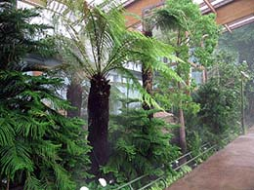
Simulated tropical forests from prehistoric Dubai

To change the microclimate of a city is difficult and to change the microclimate of an arid city is even more difficult. However, it can be done. The question is — can it be done sustainably? Is an abundant and unlimited amount of water necessary to decrease the temperature of a city and shift a microclimate? Hopefully, this “designed experiment” will prove that this can be accomplished by implementing greenscapes and greenroof design strategies; utilizing water that is otherwise wasted, treated wastewater, grey water and stormwater, to spur the growth of vegetation, reduce temperatures, and shift the microclimate. The arid regions of the world were not always dry and desolate; they once were tropical forests. “Desertification involves a decrease in biological productivity due to climatic changes or human activities ((von Hardenberg, Meron et al. 2001).” In order to mediate the process of desertification, human activities need to counteract the challenges the world is facing from climate changes. One way might be fighting desertification with urbanization.

Akbari, H., M. Pomerantz, et al. (2001). "Cool surfaces and shade trees to reduce energy use and improve air quality in urban areas." Solar Energy 70(3): 295-310.

Felson, A. J. and S. T. A. Pickett (2005). "Designed experiments: new approaches to studying urban ecosystems." Frontiers in Ecology and the Environment 3(10): 549-556.

Voelz, J. (2006). The Characteristics & Benefits of Green Roofs in Urban Environments. Sustainability and the Built Environment. Davis, California, UC Davis: 9.

von Hardenberg, J., E. Meron, et al. (2001). "Diversity of Vegetation Patterns and Desertification." Physical Review Letters 87(19): 198101.

